Change Android icon in react native

Step 1

Download any image which is suitable for your app



Step 2

Open any browser and goto

<https://easyappicon.com/>

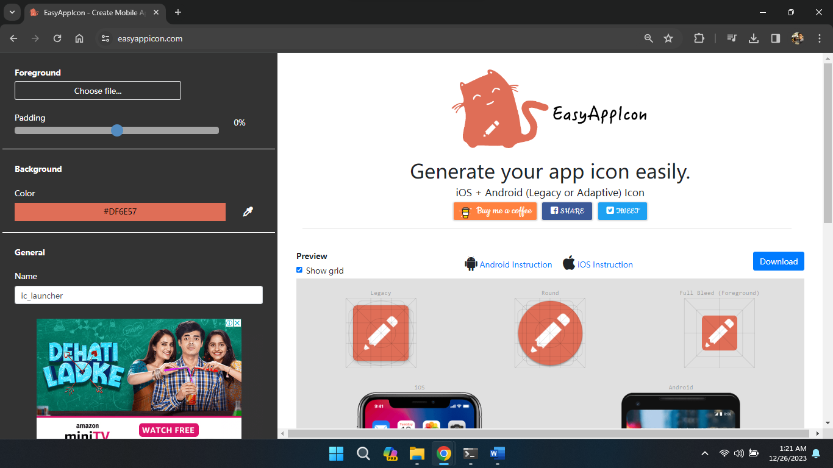

* Click on **Choose file** select your download image
* Set icon padding and set background color
* Then clock on Download

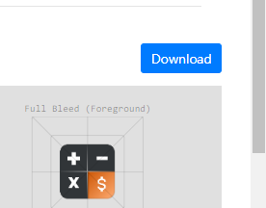

* Select **iOS + Adaptive Icons** option( it will download the app logo )



Step 3

* Extract the downloaded zip file

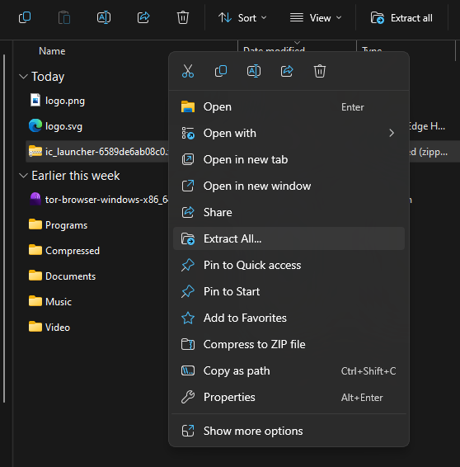

* Goto Extracted folder inside **android** folder

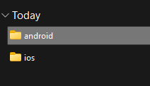

* Copy these folders

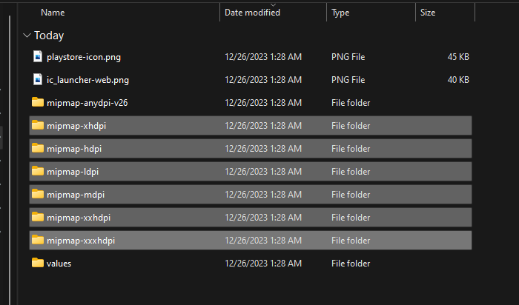

* Goto Your Project **root directory**

Then goto this path

**\android\app\src\main\res**

Then past all the **copied** folder here

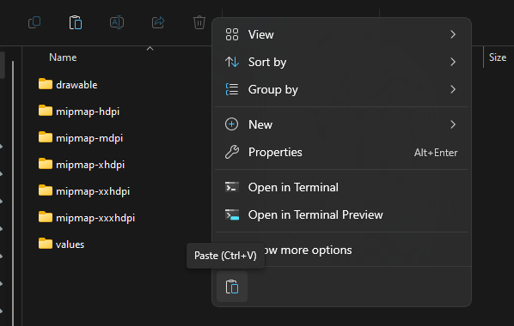

* And **replace** all the files and folders

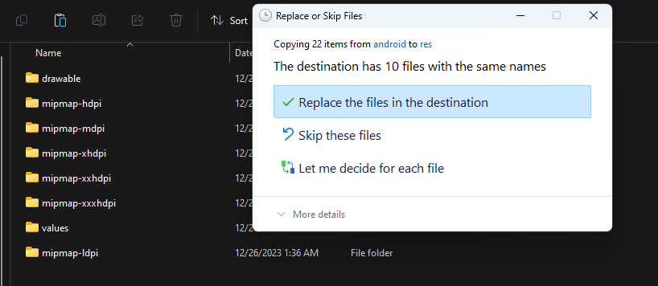

* Now open Terminal from app root directory rebuild the app

>>> npm start